Tutorial N-3
Exercise1
A discrete-time system is described by the following rule:
$$y\left[n\right]=2x\left[2n\right]+0.5x[n-1]$$
Where$x$ is the input signal, and $y$ the output signal. $x[n]$ is illustrated below:
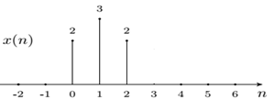
- Evaluate its Discrete Fourier Transform (DFT), i.e.
- Calculate the 4-point DFT$Y[k$] by using the decimation in time FFT method.
- Given a sequence X[K] for $0≤k≤3,$ where
$$X\left[0\right]=10, X\left[1\right]=-2+2j, X\left[2\right]=-2, X\left[3\right]=-2-2j$$
Evaluate its inverse DFT x[n] using the decimation-in-frequency FFT method.
Exercise2
Two finite sequences h and x have the following DFT's:
$$X[k] = DFT(x[n]) = \left\{1,-2, 1,-2\right\}$$
$$H[k] = DFT \left(h[n]\right)= \left\{1,j,1,-j\right\}$$
Let y[n] = 2x[n] -3h[n], using the properties of the DFT,
- Determine DFT(x [n-2]).
- Determine y[2] (do not compute x[n] and h[n]).
Table: General Properties of DFT
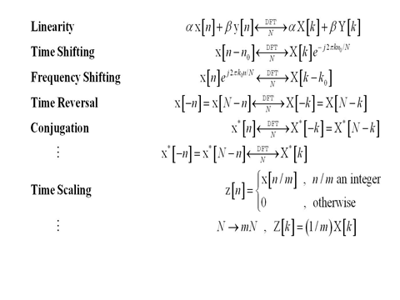
Exercise3
A real signal x(t) is sampled at 8kHz and we store 256 samples x[0], ..., x[255]. The magnitude of the DFT X[k] has two sharp peaks at k = 15 and k = 241. What can you say about the signal?
Exercise4
A narrowband signal is sampled at 8kHz and we take the DFT of 16 points as follows. Determine the best estimate of the frequency of the sinusoid, its possible range of values and an estimate of the amplitude:
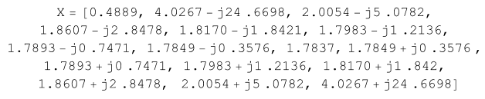
Exercise5
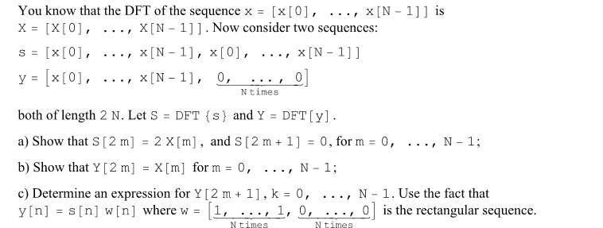
Exercise6
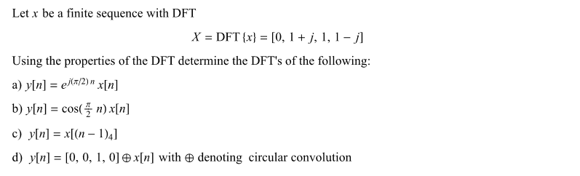
Exercise7
