STUDENT NAME: |  |  |  | SECTION:
STUDENT ID: |  |  |  | COURSE ID:
SOs # 6 | KPI 6.1 |  | KPI 6.2 | KPI 6.3 | GRADES
SCORE |  |  |  |  | R
ASSIGNMENT | LAB#4(VERIFICATION OF KIRCHOFF’S VOLTAGE AND CURRENT LAW) |  |  |  | Q
RELEVANT PARTS | DEVELOPING |  | CONDUCTING | ANALYSIS AND INTERPRETATION | T


EE 250/251
BASIC ELECTRICAL ENGINEERING
SUMER 2021
EXPERIMENT # 4
VERIFICATION OF KIRCHOFF’S VOLTAGE AND CURRENT LAW

Note: All the students are directed to do necessary theoretical calculation for the experiments and come for the laboratory session.

OBJECTIVE:
Verify Kirchhoff’s Voltage Law (KVL) and Kirchhoff’s Current Law (KCL) using mesh and nodal analysis for the given circuit.
EQUIPMENTS REQUIRED:
Sr. no | Name | Range | Quantity
1 | Resistors
2 | DC variable voltage supply
3 | Voltmeter
4 | Ammeter
5 | MULTISIM simulator

THEORY:
- KIRCHHOFF’S VOLTAGE LAW (KVL)
Kirchhoff’s Voltage Law “states that the algebraic sum of all the voltages around any closed path (loop or mesh) is zero”.
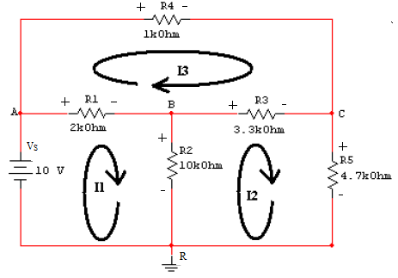
FIGURE 1.
Applying Kirchhoff’s voltage law to the first and the second loops in the circuit shown in Figure 1 yields the equation below respectively
$V_{1}+V_{2}$ $=10$ (LOOP “ABRA”) (1a)
$V_{3}+V_{5}-V_{2}=0$ (LOOP “BCRB”) (1b)
$V_{4}-V_{3}-V_{1}=0$ (LOOP “ACBA”) (1c)
PROCEDURE: KIRCHOFF’S VOLTAGE LAW (KVL)
1. Make the circuit shown in Figure 1 in MULTISIM simulator using the values shown in the circuit diagram.
2. Set the DC Power Supply (Vs) to 10 Volts.
3. Connect voltmeter at suitable places across the resistor to measure the voltage.
4. Now run the simulator and observe the voltage across each resistor.
5. Record the voltage reading from the simulation in the table below.
5. Verify the results theoretically and record the value in the observation in the column for calculated value.
6. Verify KVL for the loops in the circuit using equations ‘1a’ and ‘1b’.
OBSERVATION TABLE:
Element | Specified  value | Element Voltage | Element voltage |  |  |  | LOOP VOLTAGE “ABRA”  $V_{1}+V_{2}$ $=10$  Calculated:  Simulated :  LOOP VOLTAGE “BCRB”  $V_{3}+V_{5}-V_{2}=0$  Calculated:  Simulated:  LOOP VOLTAGE “ACBA”  $V_{4}-V_{3}-V_{1}=0$  Calculated:  Simulated:
Element | Specified  value | Element Voltage | Nodes |  | Simulated  value of voltage  (V) | Calculated value of voltage  (V)
Element | Specified  value | Element Voltage | + | − | Simulated  value of voltage  (V) | Calculated value of voltage  (V)
R₁ |  | $$V_{1}$$ | A | B
R₂ |  | $$V_{2}$$ | B | R
R₃ |  | $$V_{3}$$ | B | C
R₄ |  | $$V_{4}$$ | A | C
R₅ |  | $$V_{5}$$ | C | R
Vs |  | $$V_{s}$$ | A | R

SIMULATION RESULT: (ATTACH ANY 3 SIMULATION SNAPSHOT HERE)

- KIRCHHOFF’S CURRENT LAW (KCL):
KIRCHHOFF’S CURRENT LAW “states that the algebraic sum of all the currents at any node is zero”. Applying Kirchhoff’s current law to the nodes in the circuit shown in Figure 3 yields the following equations.
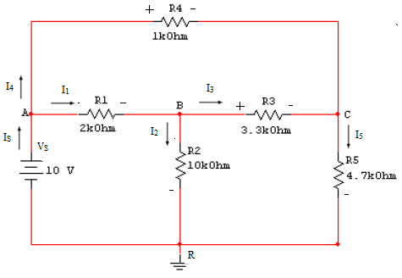
FIGURE 2.
Node A: -I_{s} + I₁ + I₄= 0 (2a)
Node B: -I₁ + I₂ + I₃ = 0 (2b)
Node C: -I₄ – I₃ + I₅= 0 (2c)
Node R: - I₂ - I₅ + I_{S}= 0 (2d)
PROCEDURE: KIRCHOFF’S Current LAW (KCL)
1. Make the circuit shown in Figure 2 .
2. Set the DC Power Supply (Vs) to 10 Volts.
3. Connect ammeter at suitable place to measure current in each branch in series with the resistor.
4. Run the simulator and observe the incoming and outgoing current at each node.
5. Record the simulation result in the observation table given below.
6. Calculate the current theoretically and record the value in the observation in the column
for calculated value.
6. Verify KCL for all the nodes in the circuit using equations ‘2a’ through ‘2d’.
FIGURE 3.

OBSERVATION TABLE:
Node | Total current  into (I_{in}) (A) |  | Total current  out of (I_{out}) (A) |  | KCL  (I_{in} – I_{out}) (A)
Node | Calculated | Simulated | Calculated | Simulated | Calculated | Simulated
A | I_{S} = | I_{S} = | I₁ =  I₄ = | I₁ =  I₄ =
B | I₁ = | I₁ = | I₂ =  I₃ = | I₂ =  I₃ =
C | I₃ =  I₄ = | I₃ =  I₁₄= | I₅ = | I₅ =
R | I₂ =  I₅ = | I₂ =  I₅ = | I_{S} = | I_{S} =

SIMULATION RESULTS : (ATTACH SIMULATION SNAPSHOT FOR I₁ ,I₂ ,I₃ ,I₄ ,I₅ ,I_{S} HERE)

REMARK:
- KIRCHHOFF’S VOLTAGE LAW(KVL):

…………………………………………………………………………………………………………………………………………………………………………………………………………………………………………………………………………………………………………………………………………………………………………………………………………………………………………………………………………………………………………………………………………………………………………………………………………………………………………………………………………………………………………………………………………………………………………………………………………………………………………………….....

- KIRCHOFF’S CURRENT LAW(KCL):
…………………………………………………………………………………………………………………………………………………………………………………………………………………………………………………………………………………………………………………………………………………………………………………………………………………………………………………………………………………………………………………………………………………………………………………………………………………………………………………………………………………………………………………………………………………………………………………………………………………………………………………….....

