STUDENT NAME: |  |  |  | SECTION:
STUDENT ID: |  |  |  | COURSE ID:
SOs # 6 | KPI 6.1 |  | KPI 6.2 | KPI 6.3 | GRADES
SCORE |  |  |  |  | R
ASSIGNMENT | LAB#5 (SUPERPOSITION THEOREM) |  |  |  | Q
RELEVANT PARTS | DEVELOPING |  | CONDUCTING | ANALYSIS AND INTERPRETATION | Q


EE 250/251
BASIC ELECTRICAL ENGINEERING
SUMMER 2021
EXPERIMENT # 5
SUPERPOSITION THEOREM

Note: All the students are directed to do necessary theoretical calculation for the experiments and come for the laboratory session.

OBJECTIVE:
The objective of this laboratory session is to apply and verify the superposition theorem to linear circuits.
EQUIPMENTS REQUIRED:
Sr. no | Name | Range | Quantity
1 | Resistors
2 | DC variable voltage supply
3 | Voltmeter
4 | Ammeter
5 | MULTISIM Simulator

THEORY:
Superposition Theorem: The voltage and current responses in a network from two or more sources acting simultaneously can be obtained as the sum of the responses from each source acting alone with other sources deactivated. A deactivated current source is an open circuit. A deactivated voltage source is a short circuit.
CIRCUIT DIAGRAM:
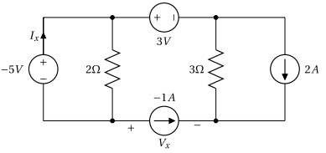
FIGURE 1.
THE SUPERPOSITION THEOREM
A : MEASUREMENT OF CURRENTS AND VOLTAGE IN CIRCUIT WITH ALL SOURCES ACTIVE.
- Connect the circuit as shown in Figure 1 in MULTISIM Simulator.
- Adjust the voltage of the power supplies to the required values.
- Use the ammeter and voltmeter to measure the current and voltage , I_{X} and V_{X} respectively.
(Note: Ammeter must be placed in series with the branch to be measured.)
- Run the simulator and observe the values of I_{x} and V_{x}.
- Record the value in Table 1.
- Verify the result theoretically and record the same in the table 1.
ADD SIMULATION SNAPSHOT HERE:

B : APPLYING THE SUPERPOSITION THEOREM
- Use the same circuit of Figure 1.
- To apply superposition theorem, deactivate all sources and keep one source active.
- For the above circuit, the -5 V, voltage source is made ACTIVE while all other sources are deactivated as shown in Figure 2.
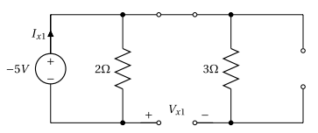
Figure 2.
- Run the simulator and measure I_{X1} and V_{X1} . Record the values in Table 2.
- Verify the result theoretically and record the same in the table 2.

ADD SIMULATION SNAPSHOT HERE:

6. Connect the circuit as shown in Figure 3. The 3V voltage source is made ACTIVE while all other sources are deactivated.
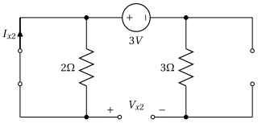
Figure 3.
7. Run the simulation and measure I_{x2} and V_{x2 .} Record the values in Table 2.
8. Verify the result theoretically and record the same in the table 2.
ADD SIMULATION SNAPSHOT HERE:

9. Connect the circuit as shown in Figure 4. The -1A current source is made ACTIVE while all other sources are deactivated.
10. Run the simulation and measure I_{x3} and V_{x3 .} Record the values in Table 2.
11 . Verify the result theoretically and record the same in the table 2.
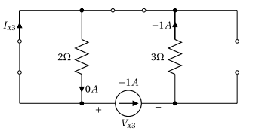
Figure 4.
ADD SIMULATION SNAPSHOT HERE:

12. Connect the circuit as shown in Figure 5. The 2A current source is made ACTIVE while all other sources are deactivated.
13. Run the simulation and measure I_{x4} and V_{x4 .} Record the values in Table 2.
14. Verify the result theoretically and record the same in the table 2.
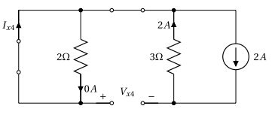
Figure 5.
ADD SIMULATION SNAPSHOT HERE:

Note:
Pay attention to the direction of the currents. Current in the same directions are added and currents in the opposite directions are subtracted.
OBSERVATION TABLE 1:
Value | Theoretical value | Simulated value
$$I_{x}(mA)$$
$$V_{x}(V)$$

OBSERVATION TABLE 2:
-5V ACTIVE |  |  | 3V ACTIVE |  |  | -1A ACTIVE |  |  | 2A ACTIVE |  |  | ALGEBRIC SUM
THT |  | SIM | THT | SIM |  | THT |  | SIM | THT |  | SIM | THEORITICAL |  | SIM
I_{X1} |  |  | I_{X2} |  |  | I_{X3} |  |  | I_{X4} |  |  | $I_{X}=$ I_{X1} + I_{X2} + I_{X3} + I_{X4}
V_{X1} |  |  | V_{X2} |  |  | V_{X3} |  |  | V_{X4} |  |  | $V_{X}=$ V_{X1} + V_{X2} + V_{X3} + V_{X4}

REMARK:
SUPERPOSITION THEOREM:
………………………………………………………………………………………………………………………………………………………………………………………………………………………………………………………………………………………………………………………………………………………………………………………………………………………………………………………………………………………………………………………………………………………………………………………………………………………………………………………………………………………………………….

