STUDENT NAME: |  |  |  | SECTION:
STUDENT ID: |  |  |  | COURSE ID:
SOs # 6 | KPI 6.1 |  | KPI 6.2 | KPI 6.3 | GRADES
SCORE |  |  |  |  | R
ASSIGNMENT | LAB#6(VERIFICATION OF THEVENIN’S AND NORTON’S THEOREM) |  |  |  | Q
RELEVANT PARTS | DEVELOPING |  | CONDUCTING | ANALYSIS AND INTERPRETATION | T


EE 250/251
BASIC ELECTRICAL ENGINEERING
SUMMER 2021
EXPERIMENT # 6
VERIFICATION OF THEVENIN’S AND NORTON’S THEOREM

Note: All the students are directed to do necessary theoretical calculation for the experiments and come for the laboratory session.

OBJECTIVE:
The objective of this laboratory session is to verify the Thevenin’s and Norton’s theorem.
EQUIPMENTS REQUIRED:
Sr. no | Name | Range | Quantity
1 | Resistors
2 | DC variable voltage supply
3 | Voltmeter
4 | Ammeter
5 | MULTISIM

THEORY:
Thévenin’s Theorem: It is a process by which a complex circuit is reduced to an equivalent series circuit consisting of a single voltage source (V_{TH}), a series resistance (R_{TH}).
OR
It states that for a linear electrical networks any combination of voltage sources, current sources and resistors with two terminals is electrically equivalent to a single voltage source (V_{TH}), in series with a single series resistor (R_{TH}) .
CIRCUIT DIAGRAM:
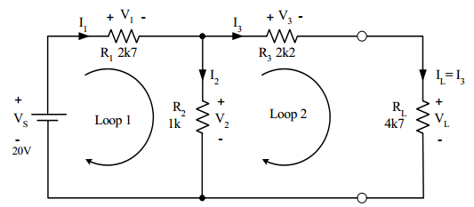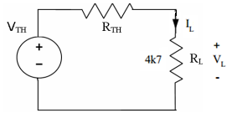
Figure 1. CIRCUIT AND ITS THEVENIN’S EQUIVALENT
Procedure:
Verifying the Thévenin’s theorem:
- Connect the circuit of Figure 1 using the component as per the values shown on it in MULTISIM simulator.
- Connect a voltmeter to measure the voltage V_{L} across the load resistance R_{L}.
- Connect an ammeter to measure the current I_{L} flowing through load resistor R_{L.}
- Run the simulator and record the voltage across the load resistor R_{L.} and current I_{L} through it.
- Record these reading in the column under the heading “BEFORE” in the table below.
- Calculate these values theoretically and record them in the table.

SIMULATION SNAPSHOT: (ADD SIMULATION RESULT HERE)

To Find V_{TH}(Thevenin voltage):
- Remove the load resistance R_{L} and measure the open circuit voltage Voc across the terminals as shown in the figure below by connecting a voltmeter at the open terminal.
- Run the simulator and record the open circuit voltage Voc.
- This open circuit voltage “Voc” is the Thevenin voltage V_{TH}.
- Calculate the Thevenin voltage V_{TH} theoretically and record in the table below.
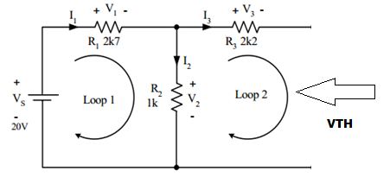
Figure 2.
SIMULATION SNAPSHOT: (ADD SIMULATION RESULT HERE)

To Find R_{TH}:
- Remove the source voltage V_{S} and replace it with a short circuit as shown if figure 3.
- Measure the resistance looking into the opening where R_{L} was with an ohmmeter as shown in figure 3.
- This resistance is the Thevenin’s equivalent resistance R_{TH}
- Calculate the value of Thevenin’s equivalent resistance R_{TH} and record in the table below.
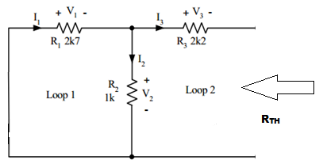
Figure 3.

SIMULATION SNAPSHOT: (ADD SIMULATION RESULT HERE)

- After Obtaining V_{TH} and R_{TH}, connect the circuit of figure 4 using these values of V_{TH} and R_{TH} in the simulator.
Figure 4.
- The above circuit is the equivalent Thevenin’s circuit.
- Measure the V_{L} and I_{L} for this circuit and record the result in the table under AFTER.
- Compare it to the V_{L} and I_{L} obtained for circuit of figure 1.
- Both these values obtained before and after reducing the circuit to Thevenin’s circuit should be the same.
- This verifies the Thévenin theorem.

SIMULATION SNAPSHOT: (ADD SIMULATION RESULT HERE)

Observation Table:
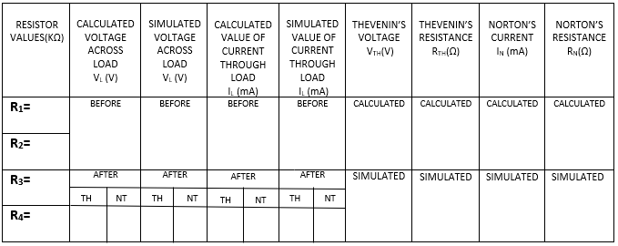
Norton's Theorem
Any collection of batteries and resistances with two terminals is electrically equivalent to an ideal current source
I_{N} in parallel with a single resistor R_{N}. The value of R_{N} is the same as that in the Thevenin equivalent and the current I_{N} can be found by dividing the open circuit voltage by R_{N}.
OR
For linear electrical networks, states that any collection of voltage sources,current sources, and resistors with two terminals is electrically equivalent to an ideal current source, I_{N} , in parallel with a single resistor,R_{N}.
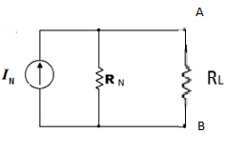
Figure 5. CIRCUIT AND ITS NORTON’S EQUIVALENT
TO FIND I_{N} OR I_{SC}:
a. Remove the load resistor from terminal A and B and short circuit the terminal as shown in figure 6.
b. Connect an ammeter through terminals A and B and run the simulator.
c. Record the current flowing through it.
c. This current is the Norton’s current “I_{N} “ or the short circuit current “I_{SC}”.
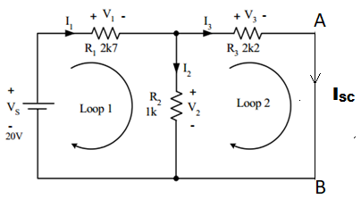
Figure 6.
d. Calculate the theoretical value for short-circuit current (I_{N}) through terminals A and B using hand calculations.
e. Record the results in the observation table below.

SIMULATION SNAPSHOT: (ADD SIMULATION RESULT HERE)

TO FIND R_{N}:
- Remove the source voltage V_{S} and replace it with a short circuit as shown in figure 7.
- Remove load resisitor R_{L} and connect ohmmeter to measure the resistance at the open terminal.
- This is the Norton’s equivalent resistance R_{N.}
- Calculate the theoretical value of R_{N} and record it in the table.
$$R_{N}=R_{Th}=\frac{V_{Th}}{I_{N}}$$
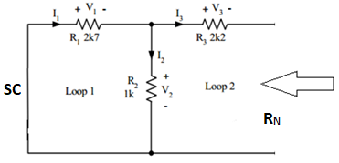
Figure 7

SIMULATION SNAPSHOT: (ADD SIMULATION RESULT HERE)

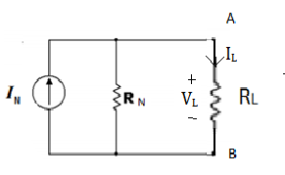
Figure 8.
VERIFYING NORTON’S THEOREM

- Construct the circuit of figure 7 using the values of $I_{N}$ and $R_{N}$in the simulator.
- Now connect the load resistance in parallel across terminal A and B as shown figure 8.
- Measure the load current and the load voltage across the Load I_{L} and V_{L} by connecting the ammeter and voltmeter at suitable places and record them in the observation table under the heading AFTER.
- Compare the experimental results before and after reducing the circuit to Norton’s and comment in the end of this report at the remark .
SIMULATION SNAPSHOT: (ADD SIMULATION RESULT HERE)

REMARK:
THEVENIN’S THEOREM:
………………………………………………………………………………………………………………………………………………………………………………………………………………………………………………………………………………………………………………………………………………………………………………………………………………………………………………………………………………………………………………………………
………………………………………………………………………………………………………………………………………………………………………………………………………………………………………………………………………………………………………………………………………………………………………………………………………………………………………………………………………………………………………………………………

NORTON’S THEOREM:
………………………………………………………………………………………………………………………………………………………………………………………………………………………………………………………………………………………………………………………………………………………………………………………………………………………………………………………………………………………………………………………………
………………………………………………………………………………………………………………………………………………………………………………………………………………………………………………………………………………………………………………………………………………………………………………………………………………………………………………………………………………………………………………………………

