Solution to a question on hidden and exposed node

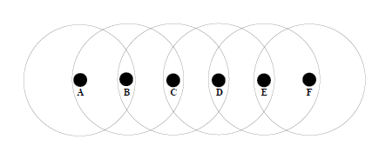

Consider the network topology in Figure ??, where circles indicate the communication
and interference range of each node, i.e. each node can hear the immediate neighbors to
the left and right. Assume that RTS/CTS is not being used.

(a) Node B currently sends to node A and node C wants to send to node D. Is node C
allowed to do so (i.e. can it do so without causing a collision) and will it decide to
do so?
Yes, node C will not cause a collision at node A. However, since node C can hear
node B’s transmission, it will not transmit.
(b) Node C sends to node B and node E wants to send to node D. Is E allowed to do so
and will it do so?
Node E’s transmission will not interfere with C’s transmission to B, however
its own transmission to D will not succeed since it will collide with node C’s
transmission. Node E is unaware of node C’s transmission and therefore it will
begin its transmission.
(c) Node A sends to node B and node D sends to node C. Which other nodes are allowed
to send at the same time?

Node E is allowed to transmit to node F. Node F could also transmit to node E, but
this transmission would collide at node E with node D’s transmission.

(d) Node A sends to node B and node E sends to node F.Which other nodes are allowed
to send at the same time?

Node C is not allowed to transmit since its transmission will collide with node A’s
transmission at node B. On the other hand, node D is allowed to transmit to node C.

