|  |  |
| --- | --- |
| **King Fahd University of Petroleum & Minerals**  **College of Engineering Sciences**  **Mechanical Engineering Department** |  |

|  |  |
| --- | --- |
| **ME 309 Mechanics of Machines** | **Spring Semester (2020-2021) (202)** |

**TERM PROJECT: Overhead Lamp**

|  |  |  |  |  |  |  |  |
| --- | --- | --- | --- | --- | --- | --- | --- |
| **Group #** |  | **Family Name**  UPPER CASE LETTERS (TYPED) | | | **First Name**  UPPER CASE LETTERS (TYPED) | | |
| |  |  | | --- | --- | | ….. | ….. | | **Student (1)** | ---------------------------------------------------------- | | | -------------------------------------------------------------- | | | |
| |  |  |  |  |  |  |  |  |  | | --- | --- | --- | --- | --- | --- | --- | --- | --- | | **2** | **0** | **1** |  |  |  |  |  | **0** | | | | | | | |
| **Student (2)** |  | |  | | | | |
| |  |  |  |  |  |  |  |  |  | | --- | --- | --- | --- | --- | --- | --- | --- | --- | | **2** | **0** | **1** |  |  |  |  |  | **0** | | | | | | | |
| **Student (3)** |  |  | | | | | |
| |  |  |  |  |  |  |  |  |  | | --- | --- | --- | --- | --- | --- | --- | --- | --- | | **2** | **0** | **1** |  |  |  |  |  | **0** | | | | | | | |
| **Student (4)** | ---------------------------------------------------------- | | | ---------------------------------------------------------- | | | |
| |  |  |  |  |  |  |  |  |  | | --- | --- | --- | --- | --- | --- | --- | --- | --- | | **2** | **0** | **1** |  |  |  |  |  | **0** | | | | | | | |
| **Student (5)** | ---------------------------------------------------------- | | | ---------------------------------------------------------- | | | |
| |  |  |  |  |  |  |  |  |  | | --- | --- | --- | --- | --- | --- | --- | --- | --- | | **2** | **0** | **1** |  |  |  |  |  | **0** | | | | | | | |
| **Tick (****) your appropriate Section #: : 🡺** | | | | 🞎 | **03** | **10:00 🡺 10:50** | |
| 🞎 | **05** | **12:00 🡺 12:50** |

**General Instructions**

1. This is a term project for ME 309: Mechanics of Machines.
2. **Read** each question **carefully**.
3. **Assume reasonably** any missing data.
4. Be **neat** and **clear** in your presentation and **show all work for full credit.**
5. **The project should be typed.**
6. A soft copy is required including word, drawing, and animation files.
7. Reference all texts you used in your search.

**Contribution of each student**

|  |  |
| --- | --- |
|  | **Contribution** |
| **Student (1)** | 1. ………………………………………………………………………………………………………..……….. 2. …………………………………………………………………………………………………………..……… 3. …………………………………………………………………………………………………………..……… 4. ……………………………………………………………………………………………………………..…… |
| **Student (2)** | 1. ………………………………………………………………………………………………………..……….. 2. …………………………………………………………………………………………………………..……… 3. …………………………………………………………………………………………………………..……… 4. ……………………………………………………………………………………………………………..…… |
| **Student (3)** | 1. ………………………………………………………………………………………………………..……….. 2. …………………………………………………………………………………………………………..……… 3. …………………………………………………………………………………………………………..……… 4. ……………………………………………………………………………………………………………..…… |
| **Student (4)** | 1. ………………………………………………………………………………………………………..……….. 2. …………………………………………………………………………………………………………..……… 3. …………………………………………………………………………………………………………..……… 4. ……………………………………………………………………………………………………………..…… |
| **Student (5)** | 1. ………………………………………………………………………………………………………..……….. 2. …………………………………………………………………………………………………………..……… 3. …………………………………………………………………………………………………………..……… 4. ……………………………………………………………………………………………………………..…… |

**Part (I): Description**

Create an overhead lamp, as shown in Figure.1. It should be capable of moving right to left, while keeping the bottom of the lamp head approximately parallel to the horizontal. Point *A* on the lamp head should be always 5.0 cm lower than any other part of the lamp. Design the lamp so that point *A* can extend out (i.e., to the right) as far as 100 cm from the wall and collapse inward as close as 40 cm to the wall. The overall mechanism height should be no more than 1.5 m when fully collapsed, and the overall mechanism length should be no more than 1.5 m when fully extended.

Start the mechanism in the fully extended position. To move the mechanism, apply a small horizontal force to the lamp head to make the mechanism close. Create a graph showing the *y* position of point *A* with respect to the *x* position of point *A*. The *y* position of point *A* should not deviate more than 5.0 cm throughout the full travel of the lamp head. Also create a graph showing the rotation angle of the lamp head, with respect to the *x* position of point *A*.

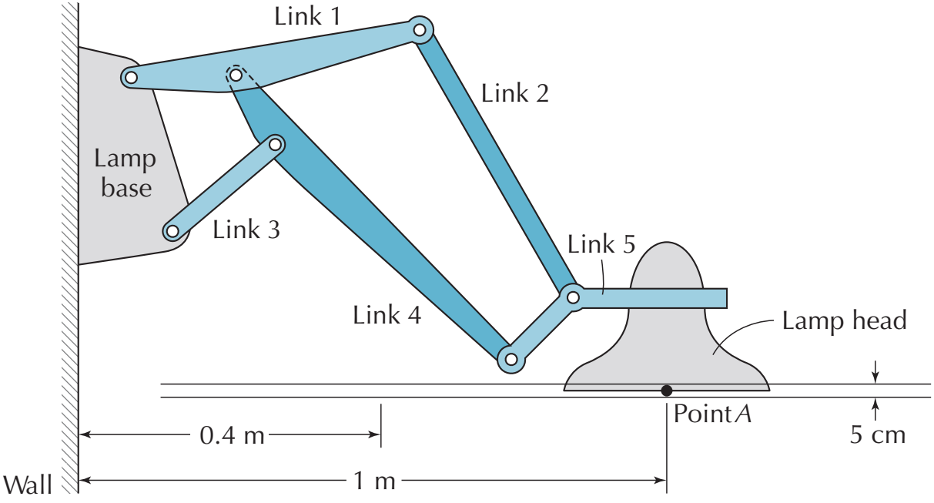

Figure.1 Overhead lamp

**Part (II): Organization of the Work**

**Software:**

* You can use software such as Solidworks or Working Model 2D or Autodesk or Autocad, whichever suitable to you.

**Cheating:**

* Consulting the website [www.chegg.com](http://www.chegg.com) for seeking solution or hint to the problem is considered as cheating and will result in assigning the student zero grade in the project.

**Notes:**

* Students are distributed into groups of maximum 5 students (with one team leader in each group).
* The contribution of each member in the project must be clearly indicated in the report.

**Requirement:**

1. Build the mechanism described by the project problem usingany of the software mentioned above that you are familiar with and then produce the animated motion. The animation should be saved as a movie file where the group number, name, and ID # of each student must appear in the animation.
2. Note that you may design and build the overhead lamp using SOLIDWORKS then import it into Working Model 2D for animation and analysis (you need to read about how to import objects into Working Model 2D from SOLIDWORKS!).

What to Submit:

1. Submit a **soft copy** of your work report (word document report) to Blackboard**.**

* Write the report in standard report format. The report must be typed and consists of a title (cover) page and 2-3 additional pages.
* The report should include an explanation of the mechanism (an accurate sketch of it with dimensions, how it works, what was your design approach, what are the difficulties you faced).
* Neatness and good organization are important when writing the final report. Hand writings (including equations) and hand-sketches are not accepted. The written report should be free of grammatical and spelling errors, and it should include cover page (attached), description of the problem, design procedure (in detail with needed diagrams and sketches), discussion and conclusion.!
* The report should be typed, and the schematic diagrams should be done by any software.
* Include any reference used in your work.

1. Submit the animation movie file to Blackboard (in a zipped folder named by your ID #).

The work will be judged on the quality of the write up of the manuscript, the technical content, and the discussion.

According to the syllabus, the grade distribution for the term project is:

***Report* 8%**

***Presentation* 2%**

***Total* 10%.**

Read the following instructions for installing Solid Works Software.

Dear All

The ME 309 students may use the below activation code for their projects. As we have limited licenses, it is recommended that the students are advised not to share it with others.

The SolidWorks ‘**Student Engineering Kit’** software can be installed on personal laptops/home PCs.

SolidWorks Student Access Activation Code: 9020009178244807ZVVSQZDD

Students can download the media from the SolidWorks website. [www.solidworks.com/SEK](https://imsva91-ctp.trendmicro.com/wis/clicktime/v1/query?url=http%3a%2f%2fwww.solidworks.com%2fSEK&umid=2AF58EDD-A0DE-1805-A5D8-A6F25DDE8B34&auth=ec34f7633709e8bd85e48c7fc0c92c09c079e558-e065e8d189505eaaeb8730e360de0f9c6df45ee6)

Use the SEK ID: XSEK12

Version: 2019-2020

This license will expire July 31, 2021

Regards,