|  |  |
| --- | --- |
| **King Fahd University of Petroleum & Minerals**  **College of Engineering Sciences**  **Mechanical Engineering Department** |  |

|  |  |
| --- | --- |
| **ME 309 Mechanics of Machines** | **Fall Session (2020-2021) (201)** |

**TERM PROJECT**

**Due Date: Tuesday 15 December 2020**

|  |  |  |  |  |  |
| --- | --- | --- | --- | --- | --- |
| **Group #** |  | **Family Name**  UPPER CASE LETTERS (TYPED) | **First Name**  UPPER CASE LETTERS (TYPED) | | |
| |  |  | | --- | --- | | ….. | ….. | | **Student (1)** | ---------------------------------------------------------- | -------------------------------------------------------------- | | | |
| |  |  |  |  |  |  |  |  |  | | --- | --- | --- | --- | --- | --- | --- | --- | --- | | **2** | **0** | **1** |  |  |  |  |  | **0** | | | | | |
| **Student (2)** | ---------------------------------------------------------- | ---------------------------------------------------------- | | | |
| |  |  |  |  |  |  |  |  |  | | --- | --- | --- | --- | --- | --- | --- | --- | --- | | **2** | **0** | **1** |  |  |  |  |  | **0** | | | | | |
| **Student (3)** | ---------------------------------------------------------- | ---------------------------------------------------------- | | | |
| |  |  |  |  |  |  |  |  |  | | --- | --- | --- | --- | --- | --- | --- | --- | --- | | **2** | **0** | **1** |  |  |  |  |  | **0** | | | | | |
| **Tick (****) your appropriate Section #: : 🡺** | | 🞎 | **02** | **09:00 🡺 09:50** | |
| 🞎 | **04** | **11:00 🡺 11:50** |

**General Instructions**

1. This is a term project for ME 309: Mechanics of Machines.
2. **Read** each question **carefully**.
3. **Assume reasonably** any missing data.
4. Be **neat** and **clear** in your presentation and **show all work for full credit.**
5. **The project should be typed.**
6. A soft copy is required including word, drawing, and animation files.
7. Reference all texts you used in your search.



**Contribution of each student**

|  |  |
| --- | --- |
|  | **Contribution** |
| **Student (1)** | 1. ………………………………………………………………………………………………………..……….. 2. …………………………………………………………………………………………………………..……… 3. …………………………………………………………………………………………………………..……… 4. ……………………………………………………………………………………………………………..…… 5. ………………………………………………………………………………………………………………..… |
| **Student (2)** | 1. ………………………………………………………………………………………………………..……….. 2. …………………………………………………………………………………………………………..……… 3. …………………………………………………………………………………………………………..……… 4. ……………………………………………………………………………………………………………..…… 5. ………………………………………………………………………………………………………………..… |
| **Student (3)** | 1. ………………………………………………………………………………………………………..……….. 2. …………………………………………………………………………………………………………..……… 3. …………………………………………………………………………………………………………..……… 4. ……………………………………………………………………………………………………………..…… 5. ………………………………………………………………………………………………………………..… |

**Part (I): Description**

Figure A.1(a) shows a traditional rocking chair. For the first part of this project, create the traditional chair using Working Model 2D or solid works or any other software you are familiar with and perform an analysis of its motion.

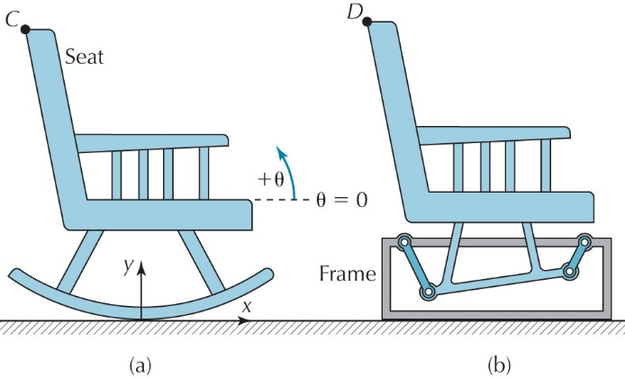

Figure A.1. Rocking chair

As shown in Figure A.1(a), θ is the angle of the seat with respect to the horizontal. The ground surface should be created directly on the x-axis. Align the center of the chair with the y-axis. Create two graphs next to your chair model, with the first showing how xc, (x position of point *C*) varies with θ, and the second showing how yc, varies with θ, for the range 

For the second part of this project, design a new rocking chair using a four-bar mechanism (Figure A.1(b)). Your new design must have motion similar to the traditional rocking chair. In order to design the motion of the new chair, add a plot of xD, versus θ to the first graph and add a plot of yD versus θ to the second graph. Attempt to match the new motion plots with the traditional chair plots as closely as possible by varying link lengths and joint positions. Employ an appropriate coordinate system for the new design. Specify the link lengths and joint positions

Employ the same seat dimensions for both chairs, and place both designs within area of the screen.

**Part (II): Organization of the Work**

**Software:**

* You can use software such as Solidworks or Working Model 2D or Autodesk or Autocad, whichever suitable to you.

**Cheating:**

* Consulting the website [www.chegg.com](http://www.chegg.com) for seeking solution or hint to the problem is considered as cheating and will result in assigning the student zero grade in the project.

**Notes:**

* Students are distributed into groups of maximum 3 students (with one team leader in each in each group).
* The contribution of each member in the project must be clearly indicated in the report.

**Requirement:**

1. Build the mechanism described by the project problem usingany of the software mentioned above that you are familiar with and then produce the animated motion. The animation should be saved as a movie file where the group number, name and ID # of each student must appear in the animation.
2. Note that you may design and build the rocking chair using SOLIDWORKS then import it into Working Model 2D for animation and analysis (you need to read about how to import objects into Working Model 2D from SOLIDWORKS!).

What to Submit:

1. Submit a **soft copy** of your work report (word document report) to Blackboard**.**

* Write the report in standard report format. The report must be typed and consists of a title (cover) page and 2-3 additional pages.
* The report should include an explanation of the mechanism (an accurate sketch of it with dimensions, how it works, what was your design approach, what are the difficulties you faced).
* Neatness and good organization are important when writing the final report. Hand writings (including equations) and hand-sketches are not accepted. The written report should be free of grammatical and spelling errors, and it should include cover page (attached), description of the problem, design procedure (in detail with needed diagrams and sketches), discussion and conclusion.!
* The report should be typed, and the schematic diagrams should be done by any software.
* Include any reference used in your work.

1. Submit the animation movie file to Blackboard (in a zipped folder named by your ID #).

Oral Presentation:Dec 13, 2017 2:00 to 5:00 PM

Due date (last day) of submission: Dec 15, 2017 Before 4:00 PM

The work will be judged on the quality of the write up of the manuscript, the technical content, and the discussion.

According to the syllabus, the grade distribution for the term project is:

***Report* 6%**

***Presentation* 4%**

***Total* 10%.**