CSE 103 - Computer Programming in C

Final Lab Exam-Term 202

Due Date: Friday 16-APR-2021 @11:59 PM

Student ID
Student Name

Please note the following instructions:
- Read the questions carefully and write a complete and working program for each question using Dev-C++ or any other IDE.
- Write comments on your code.
- Copy the codes you write for each question and paste it in this file.
- Add a screenshot of the output.
- Submit your own solution (this file including your name, ID, the codes, and screenshots) through the Blackboard before the deadline (no late submission accepted!)
- The assessment will be on the following criteria:
  - correctness of the programs.
  - comments and readability of the programs; and
  - screenshots you provide.
- All submissions will be checked for plagiarism. Similar submissions will not be graded and students are subject to dismissal

- Write a complete C program that declares an array of size 10 of datatype double, inputs 10 values from user in this array, and then displays this array on the screen. (Attach your code and sample output)
(20 points)

#include <stdio.h>
#include <stdlib.h>
int main()
{
double arr[10];
int i;
for (i=0;i<10;i++)
{
scanf("%lf",&arr[i]);
}
printf("%n");

for (i=0 ;i<10; i++)
{
printf("%lf ",arr[i]);
}
return 0;
}

// sample output

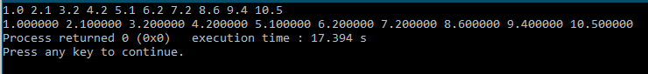

- Write a complete C program that inputs marks of a student in 5 courses using any loop and writes these marks into an output file named myElements.txt. After that, it reads scores from myElements.txt and computes the grades based on the table below using a programmer-defined function char computeGrade(double score), and displays the grades on screen. (Attach your code and sample outputs)
Score | Grade
>= 90 | A
80-89 | B
70-79 | C
60-69 | D
<= 59 | F

(40 points)
//your code
#include <stdio.h>
#include <stdlib.h>

char computeGrade(double score)
{
if (score >= 90.000000) {
return 'A';
}
else if (score >= 80.000000) {
return 'B';
}
else if (score >= 70.000000) {
return 'C';
}
else if (score >= 60.000000) {
return 'D';
}
else {
return 'F';
}
}

int main()
{
FILE *f;
f = fopen("myElements.txt","w");
int i;
double score;
for (i=0; i<5; i++)
{
scanf("%lf", &score);
fprintf(f,"%1f\n",score);
}
fclose(f);

f = fopen("myElements.txt","r");
i=0;
double line ;
line = fscanf(f, "%lf", &score);
for (i=0; i<5; i++)
{
printf("%c\n", computeGrade(score));
line = fscanf(f, "%lf", &score);
}
fclose(f);

return 0;
}

//contents of the file myElements.txt
55.000000
65.000000
80.000000
93.000000
74.000000

//sample output of the program
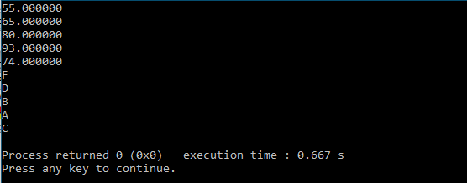
- Write a complete C program that inputs 10 integer numbers from user in an array, then it finds and displays the following:
  - maximum number in the array
  - sum of all numbers in the array
  - arrangement of numbers in ascending order using Bubble Sort algorithm.
(Attach your code and sample output)
(40 points)
//your code
#include <stdio.h>
#include <stdlib.h>

int main(){
int a[10];
int i;
int max=-200000;
int sum=0;
for(i=0;i<10;i++){
scanf("%d",&a[i]);
if (max<a[i]){
max=a[i];
}
sum+=a[i];
}
int j;
for (i=0;i<10;i++){
for (j=i+1;j<10;j++)
{
if (a[i]>a[j]){
int tmp = a[i];
a[i] = a[j];
a[j] = tmp;
}
}
}
printf("the maximum is: %d\n", max);
printf("the sum is: %d\n",sum);
for (i=0 ; i<10 ;i++)
printf("%d ",a[i]);
return 0;
}

// sample output
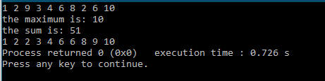

================================ End of Final Lab Exam ================================

